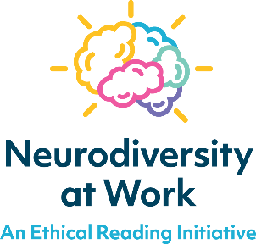
Workplace
neurodiversity passport

About me
Name: | Preferred name:
Pronouns:

I work best when…
things are clear and consistent
I’m given tasks one at a time, not all at once
I can move around between tasks
I have clear routines and expectations
I can take quiet breaks when needed
I can ask questions without feeling judged
I have extra time to process instructions
I get reminders for key tasks or times
I don’t have to multitask
I’m told in advance about changes
Other:

Things that can get in the way
Instructions that are rushed or unclear
Loud noise
Sudden interruptions
Being expected to talk in big groups
Being put on the spot with questions
When my environment keeps changing
Tasks that involve a lot of reading
Tasks that involve a lot of numbers
Feeling judged for asking for help
Lack of clear feedback
Other:

Communication preferences
Short, clear instructions
Step-by-step breakdowns
A written summary to confirm spoken instructions
Visuals, pictures or demonstrations
Time to process and respond
Regular check-ins or 1:1s
Feedback given calmly and clearly
Other:

Tools or equipment I use or might need
Earplugs or noise-cancelling headphones
Visual checklists
Coloured overlays
Large font
Task reminders or timers
Written instructions
Calculator
Spelling tools
Text to speech tools
Voice notes instead of typed messages
Other:

If I'm overwhelmed I might…
get quiet or withdrawn
walk away or need space
appear irritable or flustered
forget steps or make mistakes
Other:
What helps when that happens:
Quiet space to reset
A calm 1:1 chat
Time to regroup before continuing
A specific phrase to check in (eg “Do you need a break?”)
Other:

My strengths and ways I shine
solving problems in unusual ways
seeing the big picture
consistency and attention to detail
spotting risks or mistakes
helping people feel at ease
making people feel included
working fast under pressure
staying calm in chaos
learning by doing
Other:

Other points about me to be aware of:

